Monitoring / On-Call Approval Form

Employee Name: Nikunj Adhaduk _

Manager Name: Yaser Shadmehr
.
Monitoring Hours
Date of Monitoring (mm/dd/yyyy) | Project | Reason | Number of Hours
TOTAL

On-Call Payment
Dates On-Call (mm/dd/yyyy – mm/dd/yyyy) | # of Weeks | Rate
5/18/2025 – 5/24/2025 | 1 | 200
5/25/2025 – 5/31/2025 | 1 | 200
TOTAL |  | 400
Approvals
Employee Signature: 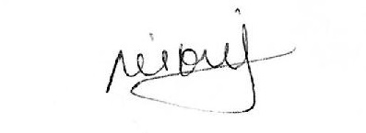 | Date:  May 30, 2025
Manager Signature: | Date:  May 30, 2025

Please submit to Payroll once approved.

Description
Date of Monitoring | Hours | Reason
May 23, 2025 | 1 | PROD support
May 28, 2025 | 3 | PROD support urgent issue of data not streaming to data lake
May 30, 2025 | 0.5 | PROD support issue where trigger started happening in batches

